# Computer Vision Hw2 Report

* Discription
  + Binarize Lena with the threshold 128
  + draw the histogram
  + connected components with

threshood 500, 4-connected component

* Algorithm
  + Binarize - 取得pixel灰階，若>threshood則設為黑

否則白色。

* + Histogram – 遍歷pixel，計算每個灰階出現的次數。
  + connected components – classical algorithm with

threshood 500, 4-connected component

* Parameters (if any)
  + no
* Principal Code Fragment

Binarize

(file – /src/cv1.util.cv /ImgUtil.java)

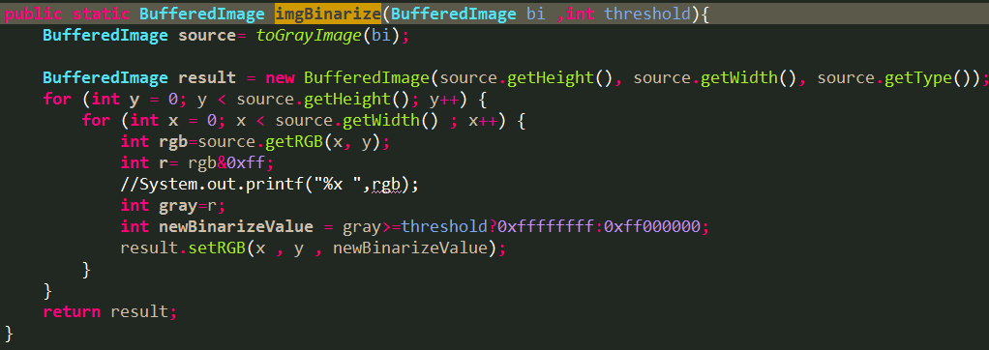

Histogram

(file – /src/cv1.util.cv /ImgUtil.java)

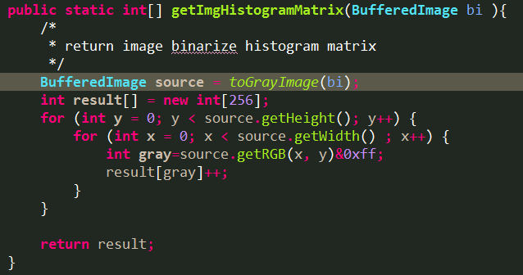

Connected Components

(file – /src/cv1.util.cv.cclabeling/ClassicalAlgorithm.java)

Step1: find connected componet by classical algorithm.

and unio set by union-find algorithm

Setp2: relabeling after union all set

and check threshood

Step3: output component and find bounding box

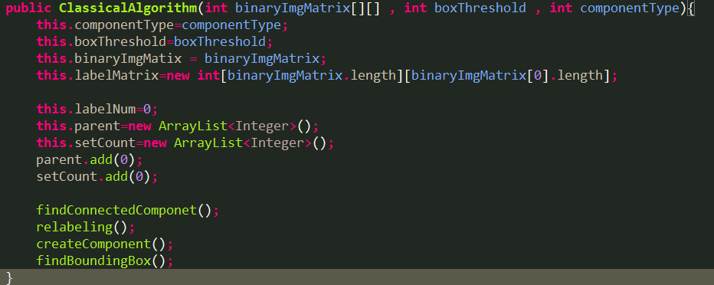

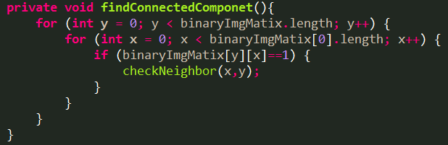

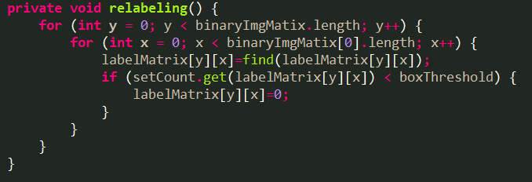

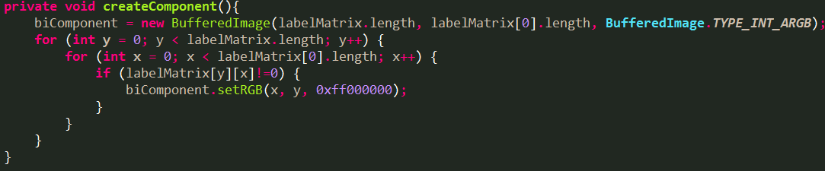

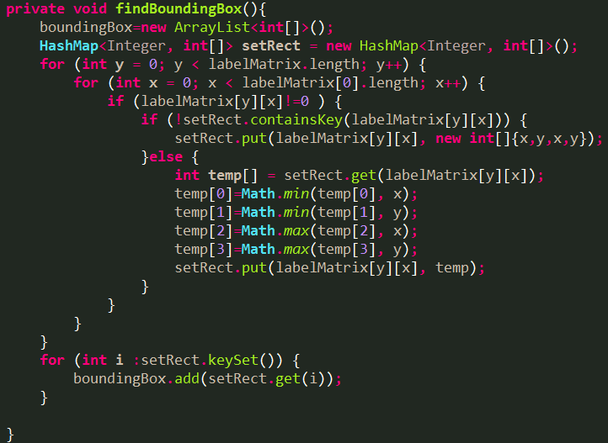

* Resulting Images

Binarize

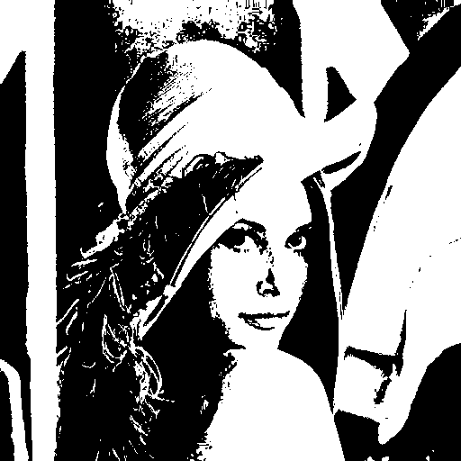

Histogram

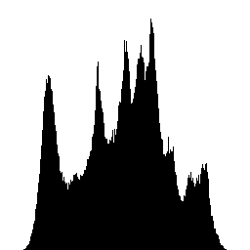

Connected Conponent (threshood = 500 ,4-connected)

